AWS Toolkit for Eclipse Setup Guide

File History:
S.No | Document Name | Version | Created By | Created Date | Modified By | Modified Date
1 | AWS Toolkit for Eclipse Setup Guide-v1.0.doc | v1.0 | Nagarjuna Goud Tummala | 03/28/2016

Step#: Start the Eclipse IDE
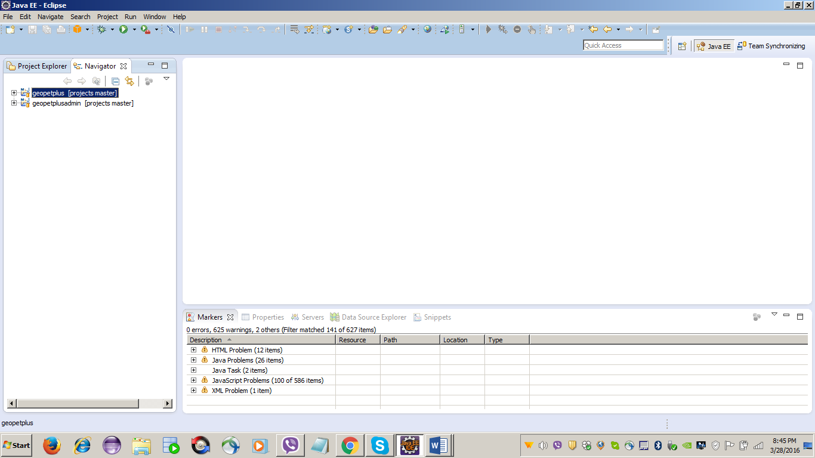

Step#: Click Help and then click Install New Software.
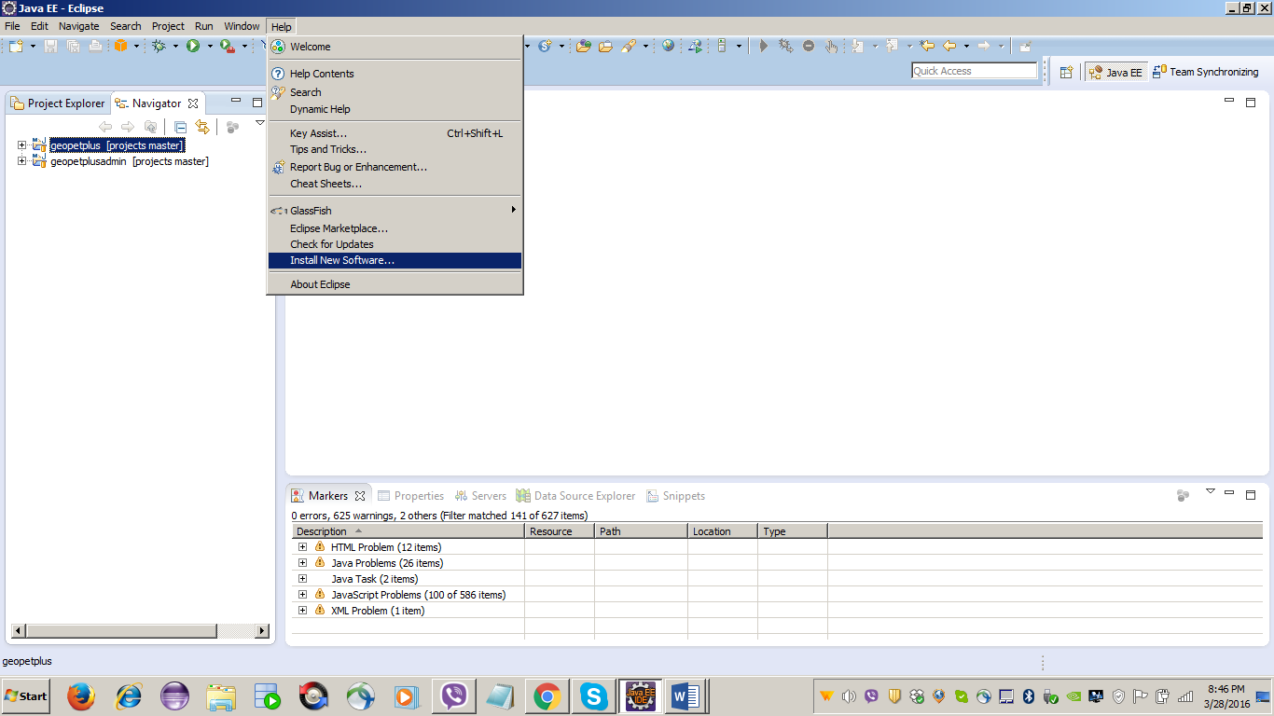

Step#:
- In the Work with box, type http://aws.amazon.com/eclipse and then press Enter.
- Click Select All and then click Next button
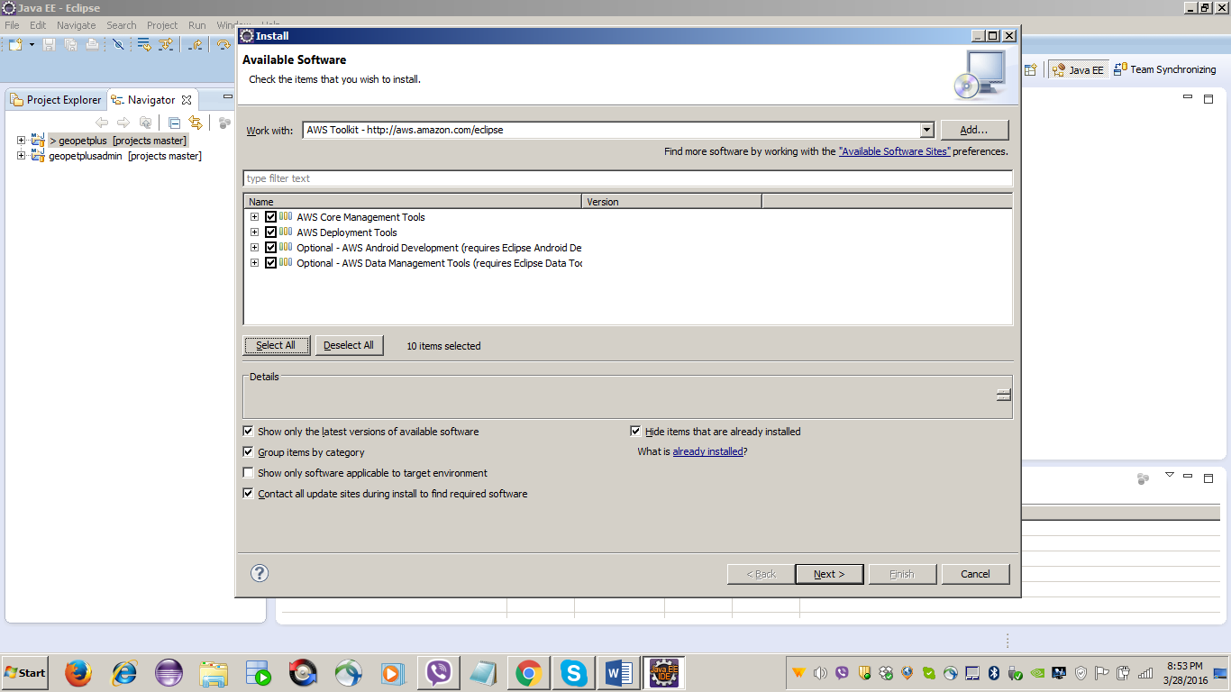

Step#: Click Next button
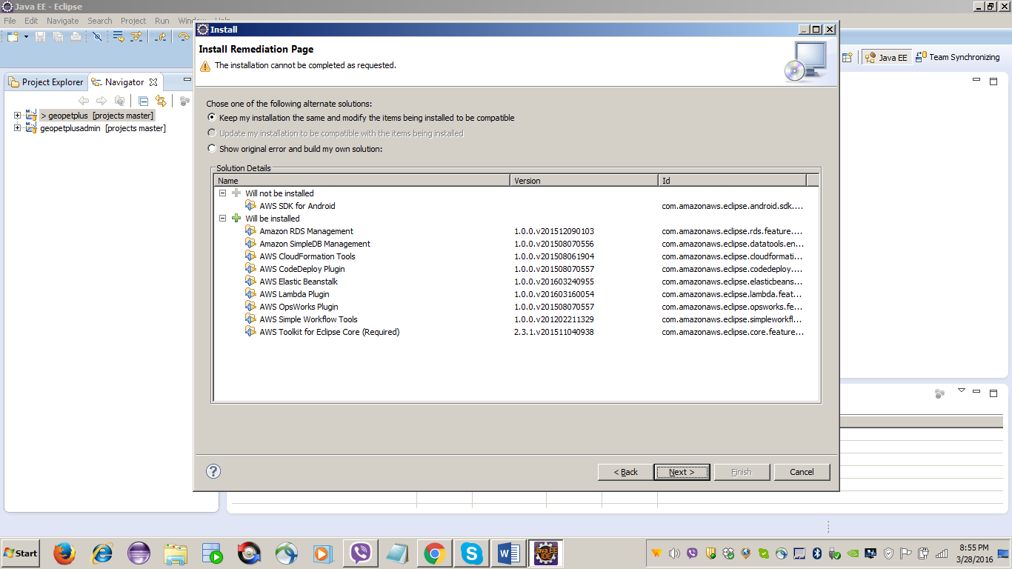

Step#: Click Next button
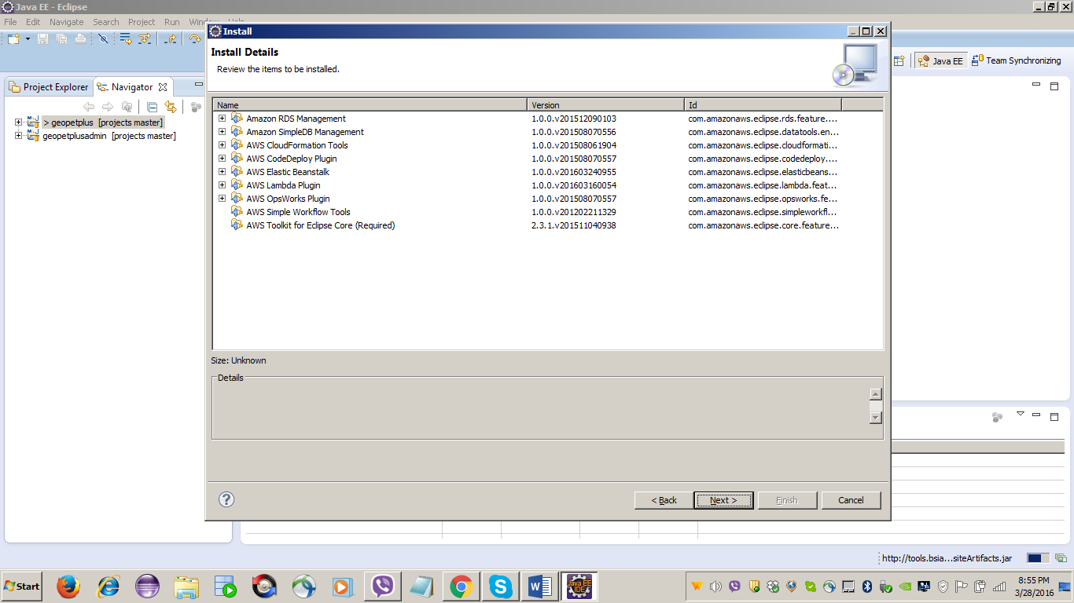

Step#: Select I accept the terms of the license agreements and Click Finish button
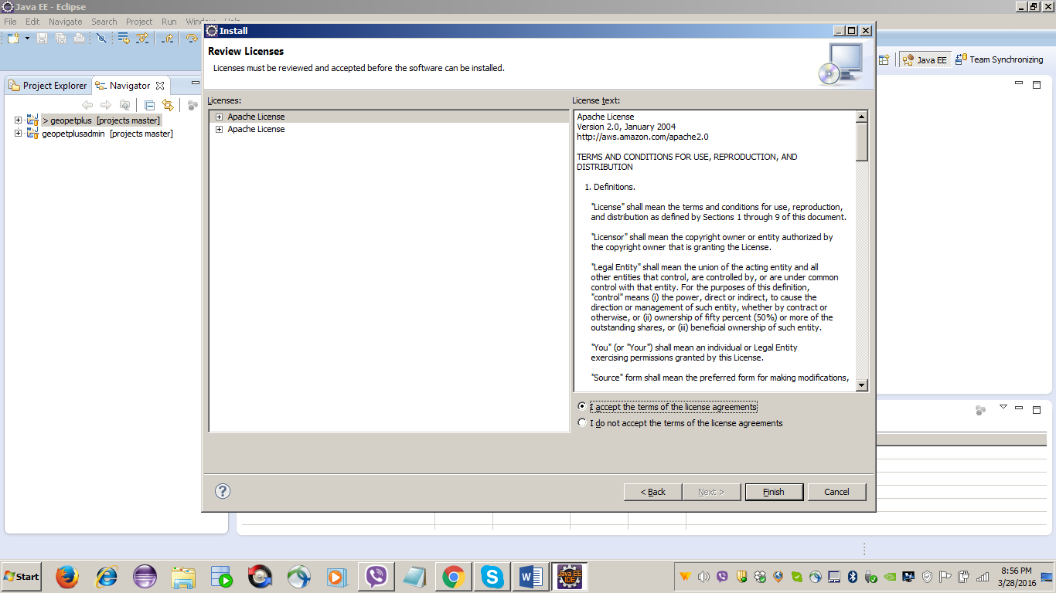

Step#: Click Yes to restart the Eclipse IDE.
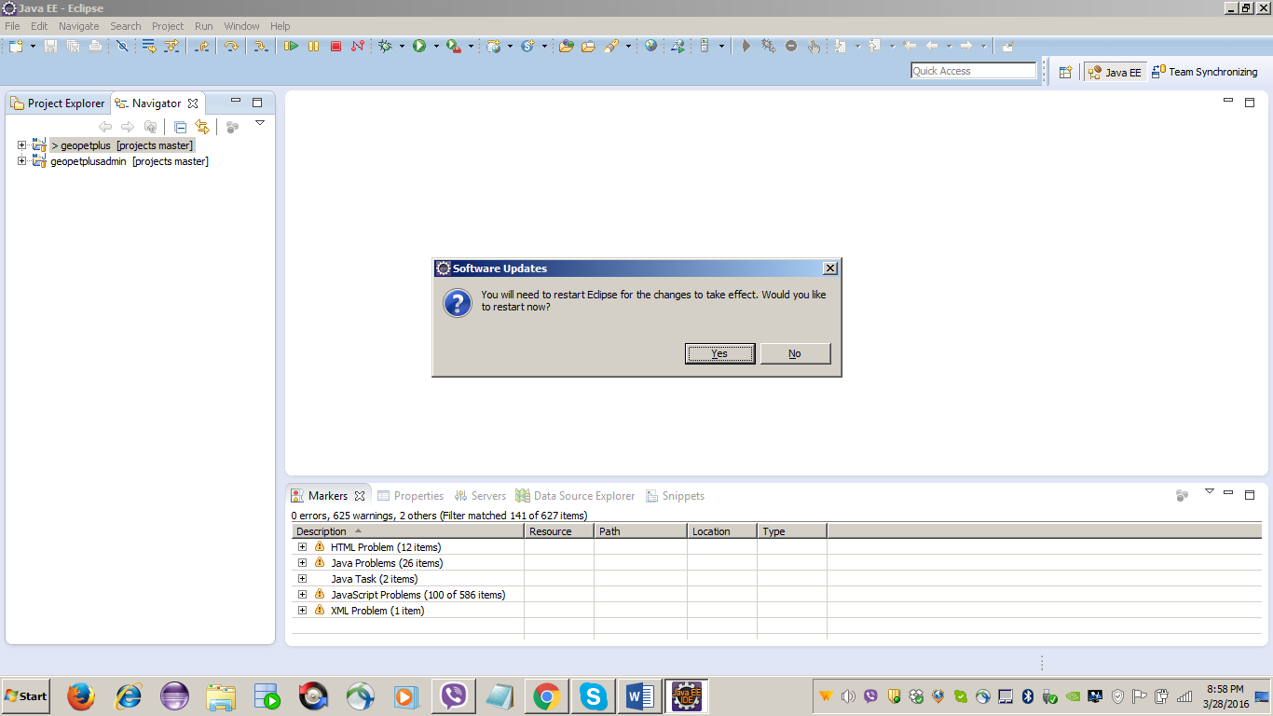

Step#: Login into Amazon Web Services (AWS) and get the Access Key ID and Secret Access Key
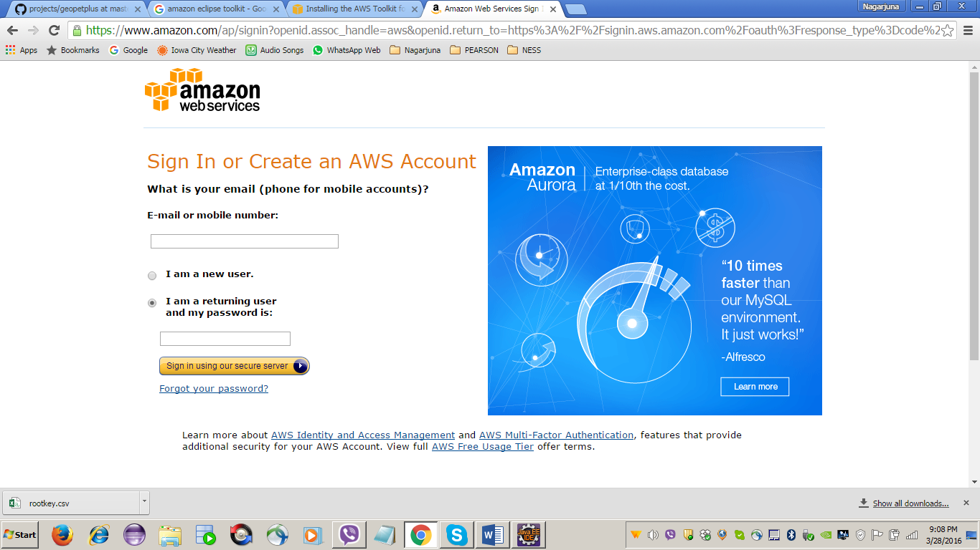

Step#:
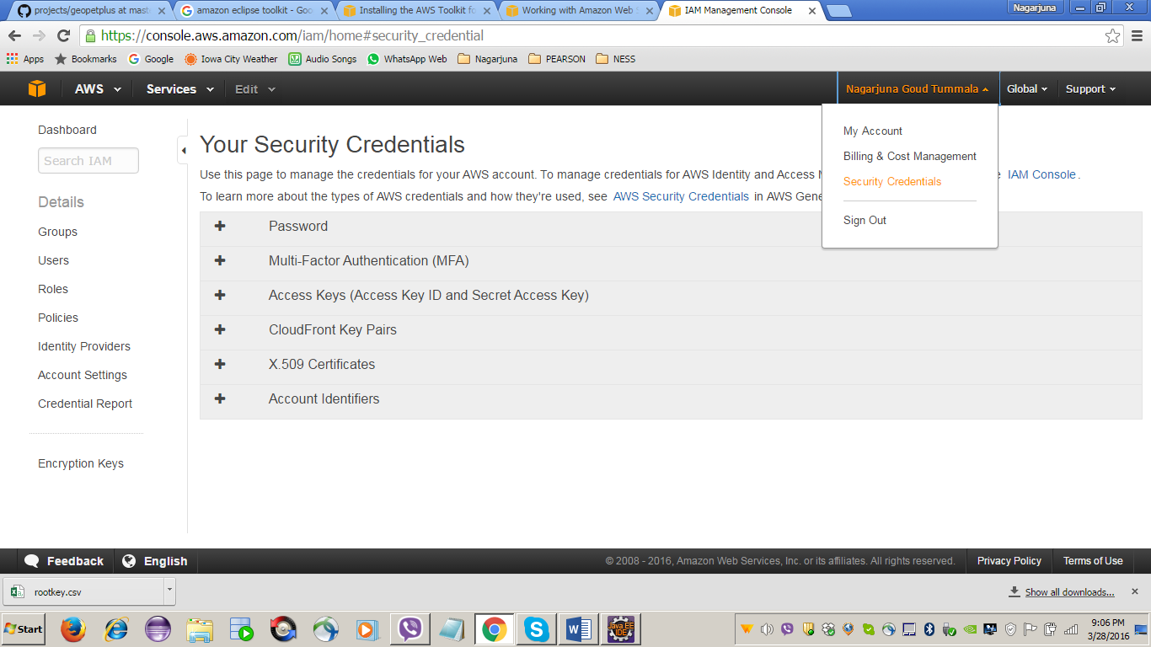

Step#: Click the Create New Access Key button to generate Access Key ID and Secret Access Key
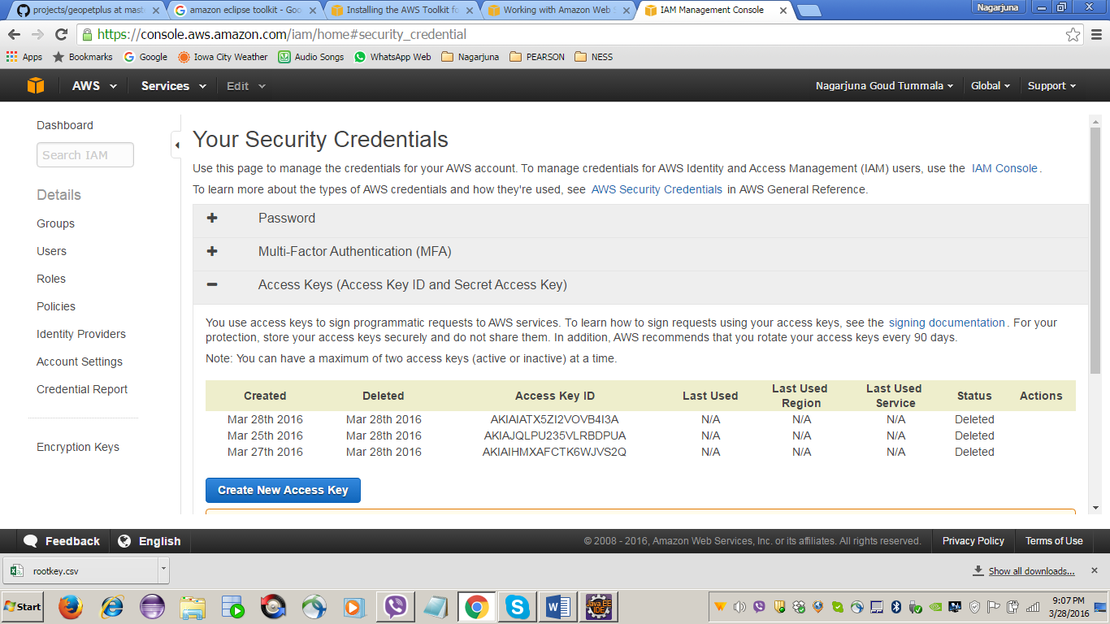

Step#: Note down the Access Key ID and Secret Access Key
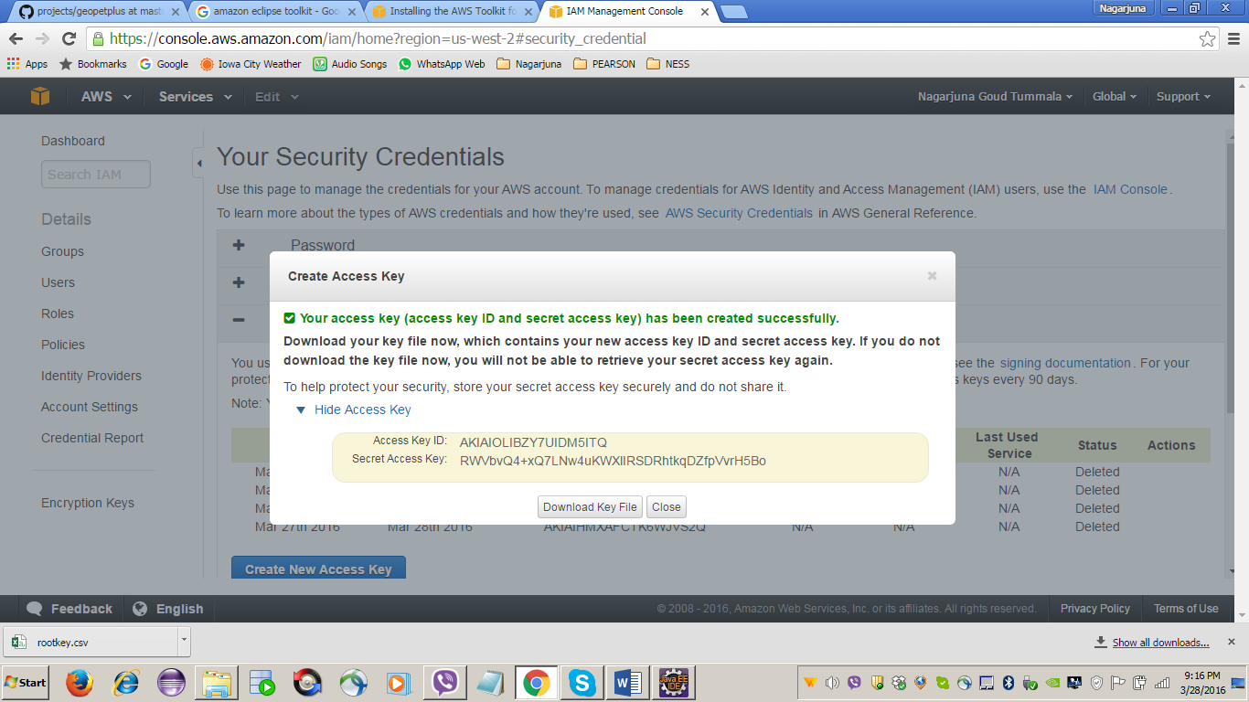

Step#: Configure the Access Key ID and Secret Access Key in Eclipse IDE
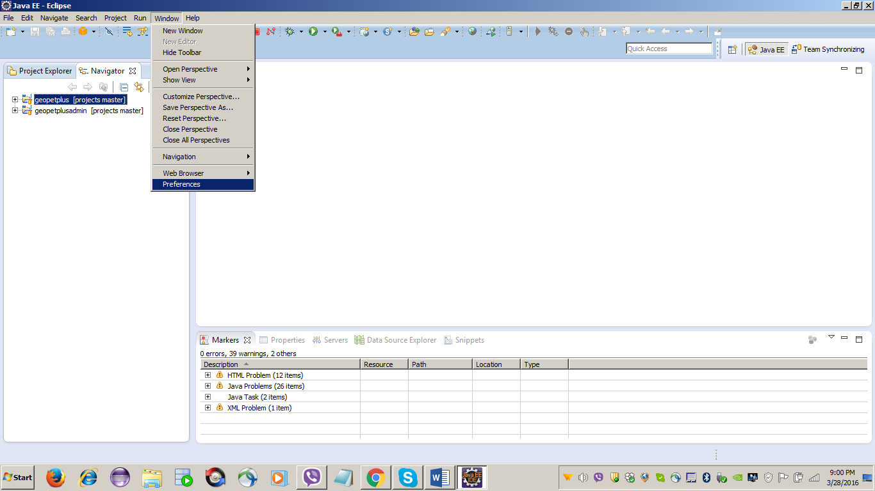

Step#: Provide the below details and click Apply and Ok button
- Profile Name
- Access Key ID
- Secret Access Key
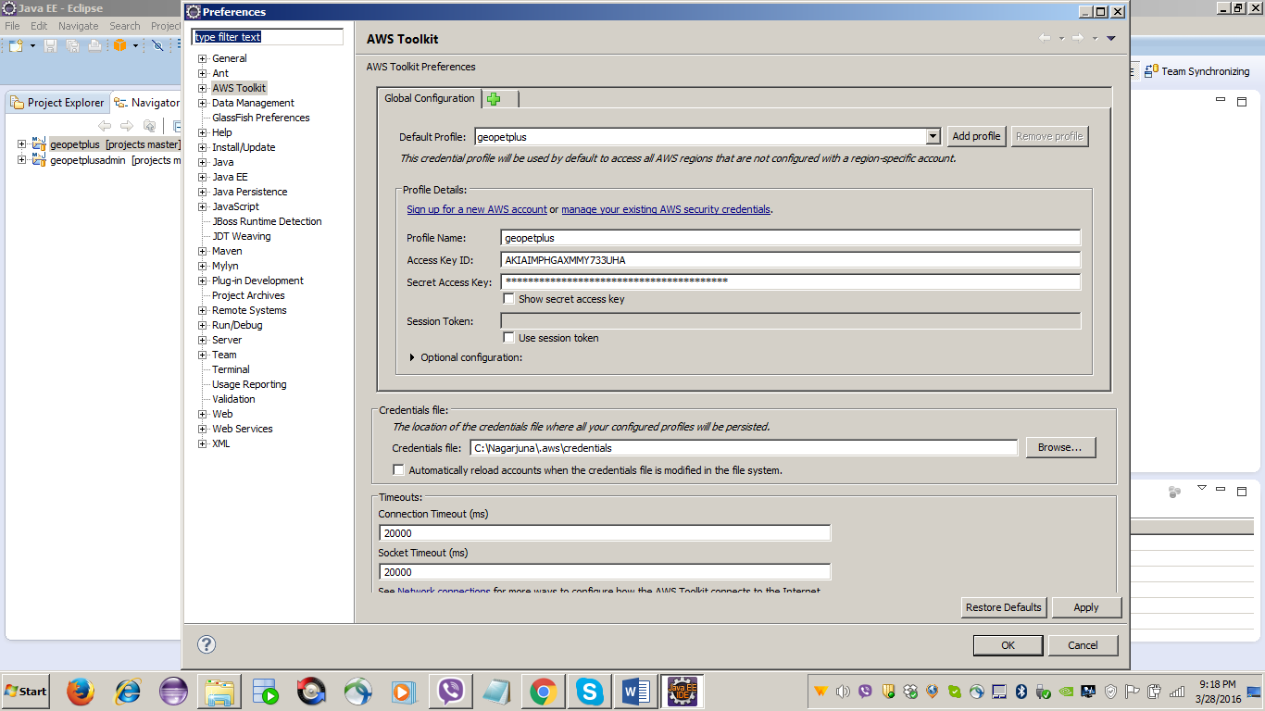
Step#:
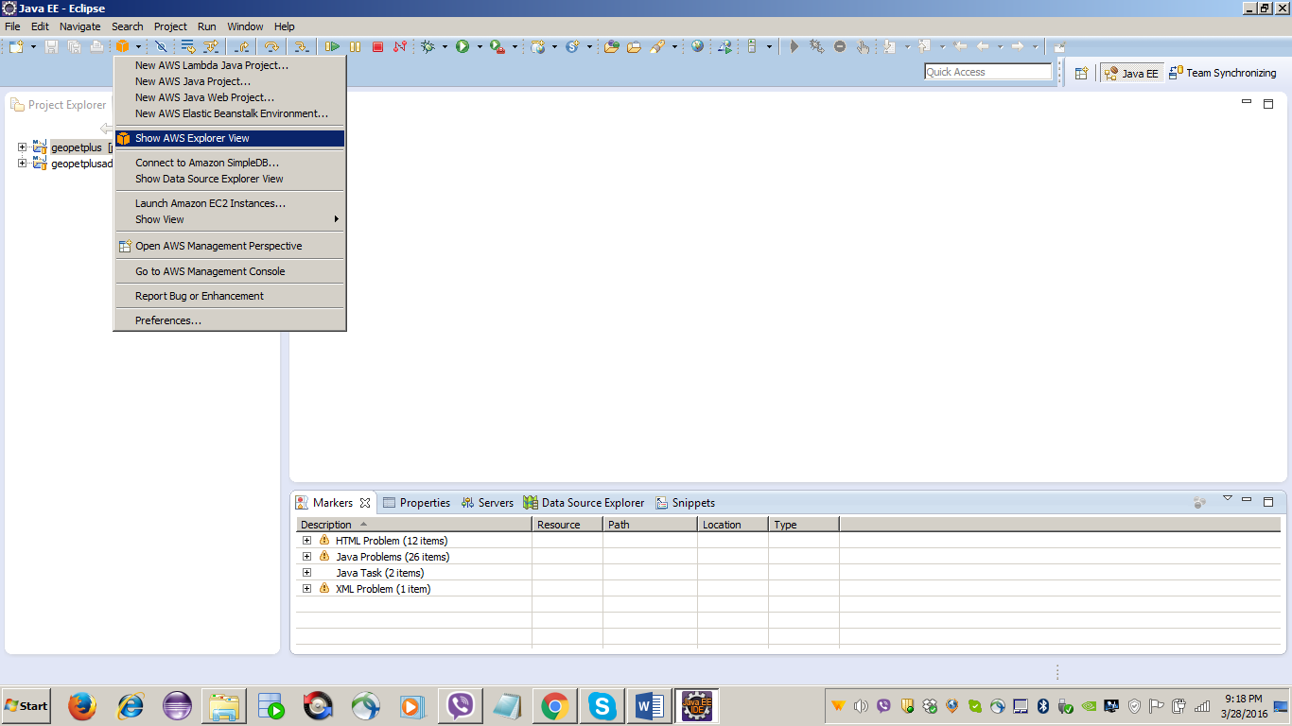

Step#:
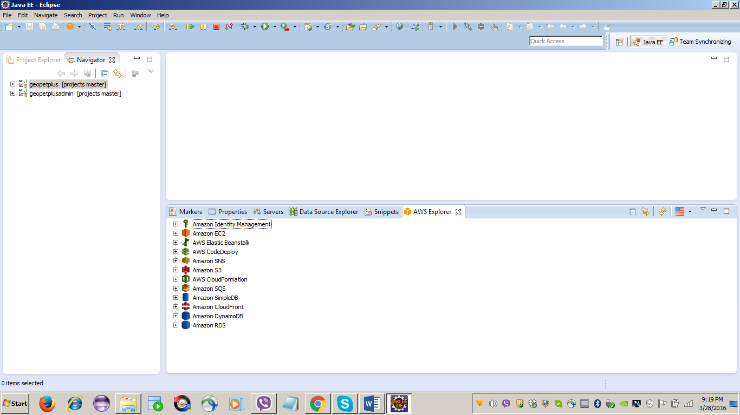

Step#: Click the below link to create the new server….
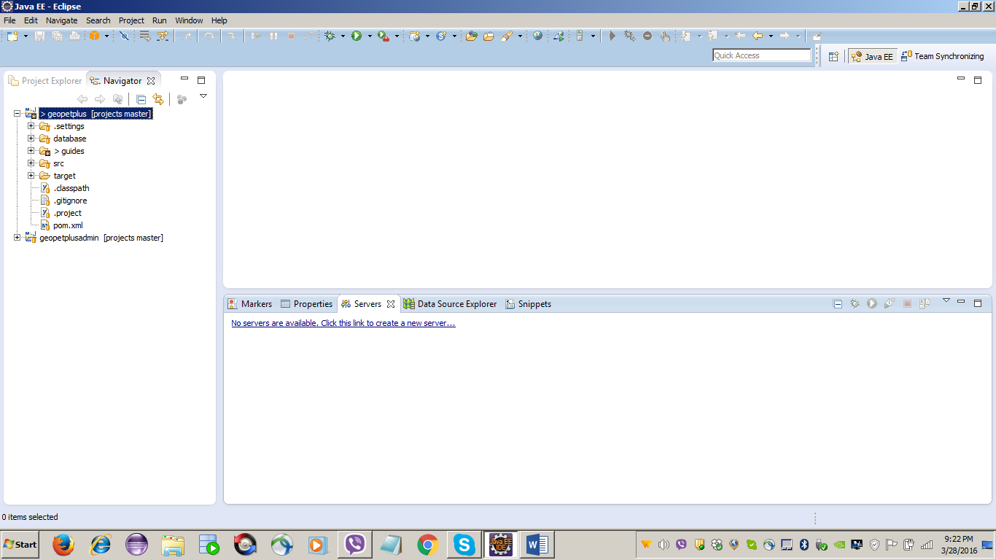

Step#: Select AWS Elastic Beanstalk for Tomcat 8 and enter AWS server’s host name and click the Next button
- Server’s host name: us-west-2.console.aws.amazon.com
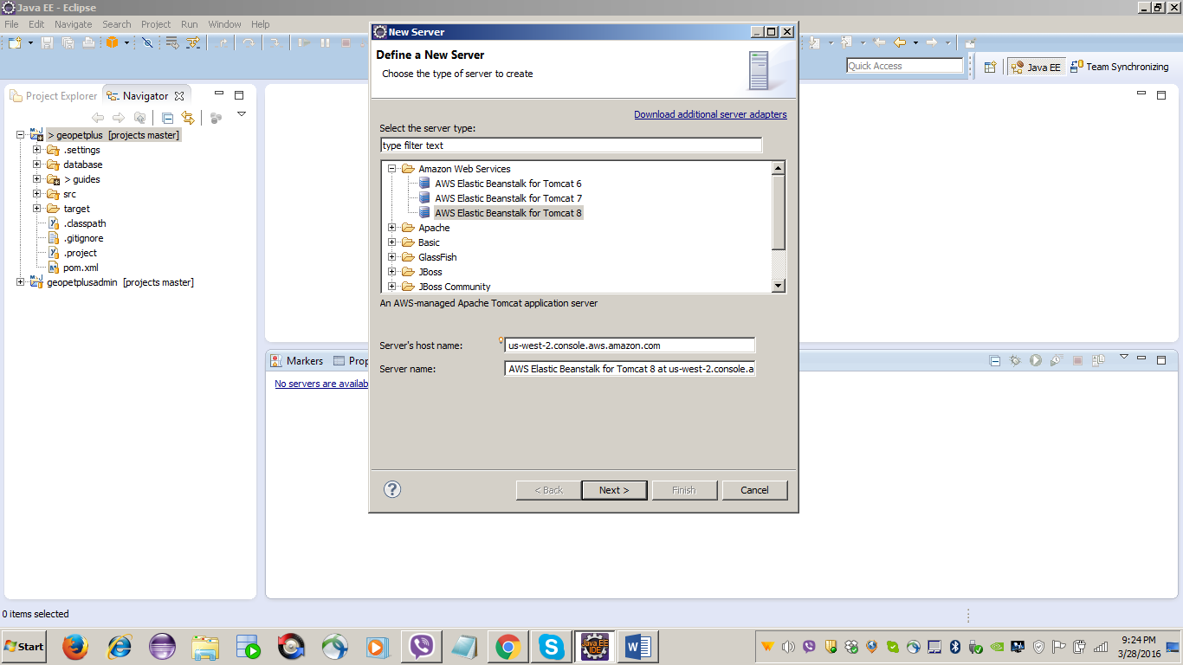

Step#: Enter the details as per the below screen and click Next button
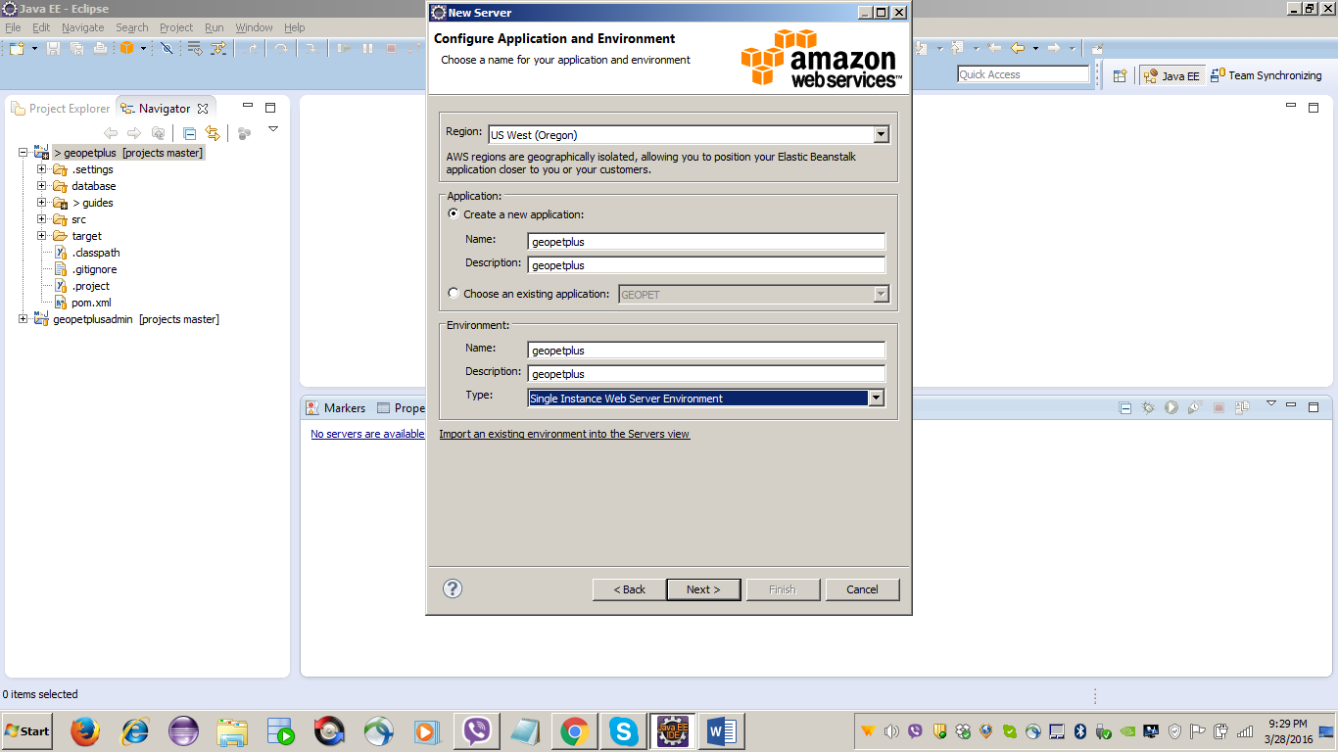

Step#: Click Next button
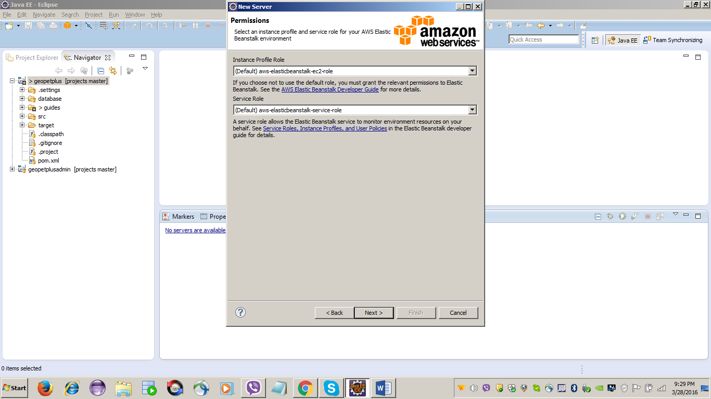

Step#: Click Next button
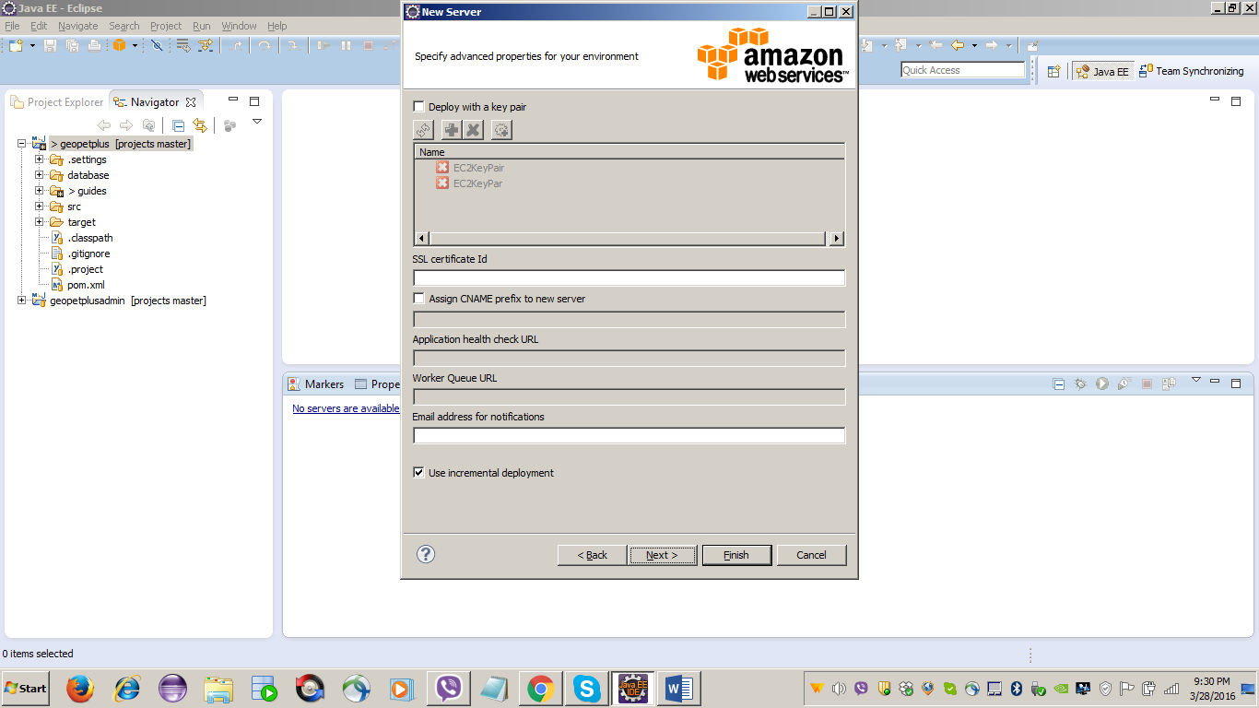

Step#: Select project and click Finish button
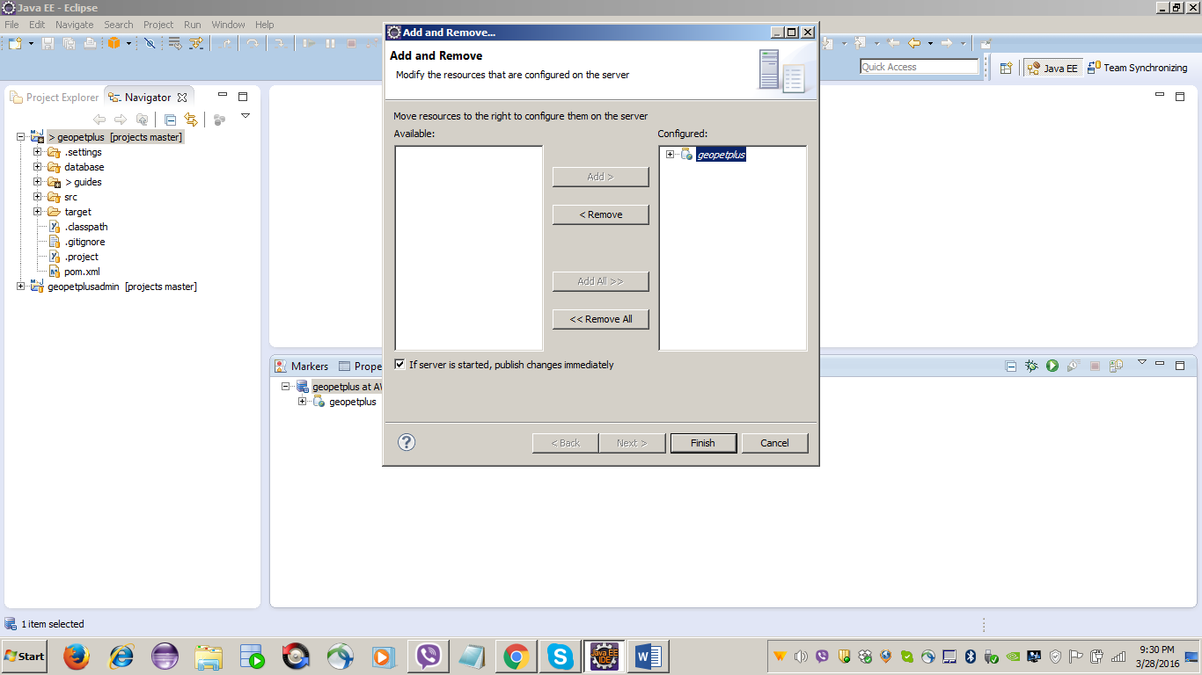

Step#: Select project and click Finish button
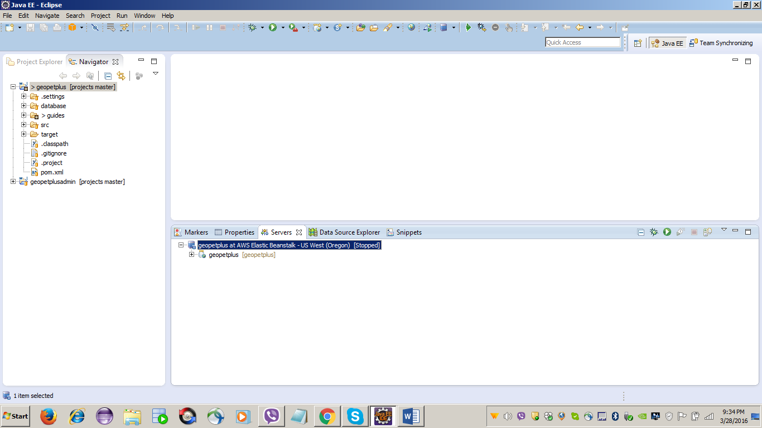

Happy Learning …!!

Thank You

